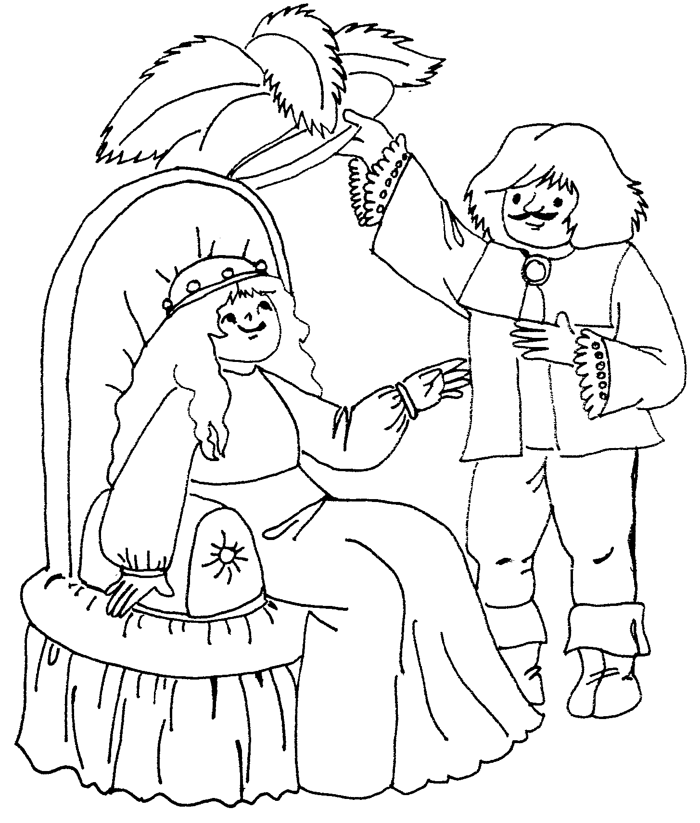

38 – 22 = 95 – 69 = 93 – 71 =
66 – 54 = 54 – 47 = 74 – 46 =
84 – 69 = 52 – 18 =
53 – 25 = 75 – 68 =
79 – 66 = 85 – 68 =
66 – 54 = 67 – 53 =
49 – 30 =

___ ___ ___ ___ ___ ___ ___ ___ , ___ ___ ___ ___ ___ ___ ___ .

1 – A 13 – J 25 – Š
2 – B 14 – K 26 – T
3 – C 15 – L 27 – Ť
4 – Č 16 – M 28 – U
5 – D 17 – N 29 – V
6 – Ď 18 – Ň 30 – W
7 – E 19 – O 31 – X
8 – F 20 – P 32 – Y
9 – G 21 – Q 33 – Z
10 – H 22 – R 34 – Ž
11 – CH 23 – Ř
12 – I 24 – S

1 – A 13 – J 25 – Š
2 – B 14 – K 26 – T
3 – C 15 – L 27 – Ť
4 – Č 16 – M 28 – U
5 – D 17 – N 29 – V
6 – Ď 18 – Ň 30 – W
7 – E 19 – O 31 – X
8 – F 20 – P 32 – Y
9 – G 21 – Q 33 – Z
10 – H 22 – R 34 – Ž
11 – CH 23 – Ř
12 – I 24 – S

